**Pareto Diagram**

A combined bar & line graph used to determine the frequency and/or significance of problems or causes of problems

**WHY**

Identifying the major contributing causes of the problem allows the improvement focus to be on those causes that will yield the biggest gains, if addressed

**WHEN**

Analyzing data, especially when there are many different causes to a problem, in order to focus on addressing the most significant causes

**HOW TO**

1. Determine the categories into which the data will be divided – can be errors or defects or causes of errors or defects
2. If data must be collected, create a Data Collection Plan
3. Create a Pareto Diagram
   1. Tabulate the Scores 🡪 Populate the template table:
      1. Sort data into pre-determined categories; Sub-total each category
      2. Tabulate the total number of causes or errors
      3. Rank/order the categories from most to least
      4. Calculate the percentage of each category and the cumulative percentages
   2. Create the diagram/graph:
      1. Complete the bar graph portion of the Pareto Chart
         1. The left vertical axis – Order the frequency of each category starting with the tallest bar (most frequent) on the left and proceeding to the shortest bar (least frequent) on the right. If there are several smaller categories, combine them all into an “Other” category
      2. Then complete the line portion of the Pareto chart
         1. The right vertical axis (Scaled from 0-100%) – Using the percentages, create the line to represent the cumulative percentage of all the causes as it tracks across the graph from left to right (reaching 100% at the right axis)
4. Interpret a Pareto Diagram - Resulting graph will visually demonstrate the most significant causes; A Pareto effect will be seen when the few significant causes are responsible for approximately 80% of the problem (80/20 Rule)
5. Acting on a Pareto Diagram - Addressing these few most significant causes will likely solve the problem

|  |
| --- |
| **TIPS**  The tabulations can be calculated and charted using the Template Table or the chart can easily be created in Excel. |

**Resources:**

* Pareto Chart <http://asq.org/learn-about-quality/cause-analysis-tools/overview/pareto.html>

**Template:**

* Pareto Chart Table
* Excel Spreadsheet - Enter data - categories (text) and subtotals (numbers) in two columns and select both columns 🡪 Choose Insert 🡪 Select the “Statistical Chart” icon 🡪 Select Histogram 🡪 Select Pareto Chart

**Pareto Diagram Table**

|  |  |  |  |
| --- | --- | --- | --- |
| **Category of Defects** | **Frequency** | **Percentage (%)\*** | **Cumulative %\*** |
|  |  |  |  |
|  |  |  |  |
|  |  |  |  |
|  |  |  |  |
|  |  |  |  |
|  |  |  |  |
|  |  |  |  |
|  |  |  |  |
|  |  |  |  |
|  |  |  |  |
|  |  |  |  |
|  |  |  |  |
|  |  |  |  |
|  |  |  |  |
|  |  | *May be calculated to create Diagram | |

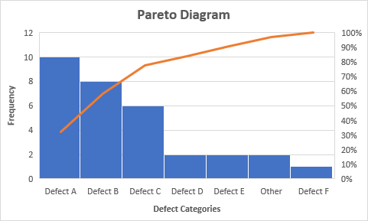

**Pareto** **Diagram**

Easily created using an Excel spreadsheet