Process Mapping
A visual documentation (picture) of the sequence of steps in any process
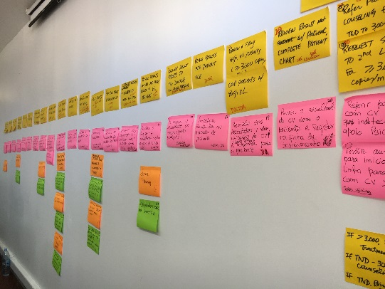
WHY
To improve a process, you must first see and understand the process.
- See - The process map is visual. Visual information is a more efficient way of communication.
- Understand
  - Help everyone to see the entire process and their place in the process
  - Clearly define the current process or variation in the process; Understand what is actually happening
  - Identify wasteful steps and inefficiencies
- Improve
  - Improving the process by eliminating the wasteful steps and/or reordering the steps for maximum efficiency
  - A visual picture of the future (improved) state PM can be created & communicated
  - The improved PM can be used as a tool to orient new staff & train according to new standard work

WHEN
Throughout the DMAIC process:
- Define - to capture current state
- Measure & ANALYZE - to understand the waste, bottlenecks & inefficiencies identified
- Improve & Control - to capture & communicate the future (Improved) state

HOW TO
- Prepare for Process Mapping
(Also see “QI Collaborative Pre-Workshop Planning and Preparation” Tool)
- Establish & engage the key stakeholders
- Define the process to be studied
- Identify all the cadres who will be involved in (i.e. touch) the process. Invite one representative from each cadre to participate in the process mapping sessions.
- Prepare Materials – Flip Chart paper, markers, self-stick notes
- Complete logistical details – location, date, time, place, transportation & Invitation
- Assign a scribe who will transcribe the paper-based process map into an electronic format

- Draft Process Map & Table – Current State (in a Conference Room)
- Develop a first draft of the process map using self-stick notes/flipchart paper
  - Begin by obtaining the high-level steps in the process
  - Allow all cadres an opportunity to share their perspectives on the process
- Complete draft process table by identifying:
  - What happens at each step
  - Who performs the activities
  - Time for each step (approximate range)
  - Documents/Forms for each step
  - Identify “Opportunities for Improvement” (OFIs)

- Go & See
- Observe the care process to validate the process map
  - Walk to observe each step of the process
  - Speak to the person who performs the process step
  - Ask the person:
    - “What happens here?”
    - “Who is responsible?”
    - “Approximately, how long does it take?”
    - “What forms are needed?”
  - Record your findings in the Process Table
  - Look/Listen & Record all OFIs
  - Move to the next step in the process
- Each team member will record the process steps (process table) and any OFIs (self-stick notes)

- Update Process Map & Table – Current State (in a Conference Room)
  - Using the collected information, validate or update the draft process map (flip chart & self-stick notes) as needed
  - Using the collected information, validate or update as needed the draft process table
  - Create an electronic version of the Process Map/Table – Current State (e.g., PowerPoint or Visio)
  - Circulate to team members to assure accuracy and a clear representation of the current process

- Place Opportunities for Improvement (OFIs) Self-Stick Notes on a Flip Chart (in a Conference Room)
- Collect OFIs on Flip Chart in preparation for next steps: Brainstorming Affinity Diagram Prioritization of OFIs using the Impact/Effort Grid

- The Improved Process – The Future State Map
- After the new process is established, prepare & distribute the Process Map - Future State to highlight the outcomes of the improvement process to the team & stakeholders
- Post the Future State Map on Learning Board to show/train staff in the new process, i.e., the new way to work

TIPS
- Capturing the Current State – Use pose-it notes on flipchart paper to facilitate discussion and modification until an accurate “picture” of the current process is captured. If you need to send the process map to someone, take a picture of the flipchart and email it.
- Capturing the Future State – At the end of the project, document the improved process with a future state map., a required deliverable for the project.

Templates:
- Process Table

Associated Tools:
- QI Collaborative Pre-Workshop Planning and Preparation
- Brainstorming / Affinity Diagram
- Impact Effort Grid
- Standard Work

Resources:
http://www.ihi.org/resources/Pages/Tools/Quality-Improvement-Essentials-Toolkit.aspx

Process Table

Process step | What happens? | Who is responsible? | Duration | Forms/logs | Opportunities for improvement

